**DEPT. OF ELECTRICAL & ELECTRONICS ENGINEERING SRM INSTITUTE OF SCIENCE AND TECHNOLOGY, Kattankulathur – 603203.**

|  |
| --- |
| Title of Experiment : **8. Wave shaping circuits ( Half wave & Full**  **Rectifiers, Clippers)** |
| Name of the candidate : Debarghya Barik    Register Number : RA2011026010022    Date of Experiment : 11.11.2020 |

|  |  |  |  |
| --- | --- | --- | --- |
| Sl.  No. | Marks Split up | Maximum marks  (50) | Marks obtained |
| 1 | Pre Lab questions | 5 |  |
| 2 | Preparation of observation | 15 |  |
| 3 | Execution of experiment | 15 |  |
| 4 | Calculation / Evaluation of Result | 10 |  |
| 5 | Post Lab questions | 5 |  |
|  | **Total** | **50** |  |

# Staff Signature

# PRE-LAB QUESTIONS (Rectifiers)

1. **What is the necessity of rectifier?**

**Ans:** All electrical appliances use a DC power supply to function. Using a rectifier in the power supply helps in converting AC to DC power supply, i.e. in other word a Rectifier is an electrical device that converts alternating current (AC), which is periodically reverse direction, to Direct current (DC), which is only in one direction and this process is known as rectification.

1. **What is PIV of a diode in Full Wave Rectifier (FWR) and Half Wave Rectifier (HWR)?**

**Ans: Peak inverse voltage** (**PIV**) is 2Vmax in centre tapped **full wave rectifier**. By using a centre tapped transformer we create two AC sources which are out of phase by 180° but with same amplitude of Vmax. **Peak Inverse Voltage** (**PIV**) or Peak Reverse Voltage (PRV) refer to the maximum voltage a **diode** or other device can withstand in the reverse-biased direction before breakdown. If a voltage is applied more than the **PIV**, the **diode** will be destroyed.

1. **What is ripple factor? Why it is required?**

**Ans: Ripple factor** is the ratio of the AC component's RMS value and the DC component's RMS value within the output of the rectifier. The symbol is denoted with “γ”.

Ripple factor is very important in deciding the effectiveness of a rectifier. The smaller this component, the more effective is the rectifier.

1. **Why are filters connected at the output of rectifiers?**

**Ans:** The **filter** is a device that allows passing the dc component of the load and blocks the ac component of the **rectifier output**. Thus, the **output** of the **filter** circuit will be a steady dc voltage.

1. **What are the types of filters used in rectifier? And which is better and why?**

# Types of filters

**Ans:** There are mainly two different types of filters used in rectifier. They are, Inductors and Capacitors. Depending upon on the placement of inductor and capacitors we can have **L - Section filter**which consists of one inductor in series and capacitor in p arallel and **pi section filter** which consists of 2 capacitor in Parallel along with inductor in between connected in series.

Among the two, the **pi section filter** is better. There are several reasons for that,

In this circuit, we have a capacitor in parallel, then an inductor in series, followed by another capacitor in parallel.

* **Capacitor C1** − This filter capacitor offers high reactance to dc and low reactance to ac signal. After grounding the ac components present in the signal, the signal passes to the inductor for further filtration.
* **Inductor L** − This inductor offers low reactance to dc components, while blocking the ac components if any got managed to pass, through the capacitor C1.
* **Capacitor C2** − Now the signal is further smoothened using this capacitor so that it allows any ac component present in the signal, which the inductor has failed to block.

Thus we, get the desired pure dc output at the load.

|  |  |
| --- | --- |
| **Experiment No. 8 a) Date :** | **SINGLE PHASE HALF WAVE RECTIFIER** |

# Aim

To construct a half wave rectifier using diode and to draw its performance characteristics. **Apparatus Required Components Required**

|  |  |  |  |  |  |  |  |  |
| --- | --- | --- | --- | --- | --- | --- | --- | --- |
| **S.**  **No.** | **Name** | **Range** | **Qty** |  | **S.**  **No.** | **Name** | **Range** | **Qty** |
| 1 | Transformer | 230/(6-0-6)V | 1 | 1 | Diode | IN4007 | 1 |
| 2 | R.P.S | (0-30)V | 2 |
| 2 | Resistor | 1K  | 1 |
| 3 | Bread Board | - | 1 |
| 4 | Capacitor | 100µf | 1 |
| 5 | CRO | - | 1 |

**Formulae**

# Without Filter

1. Vrms = Vm / 2
2. Vdc = Vm / 
3. Ripple Factor = ((Vrms / Vdc)2 – 1)
4. Efficiency = (Vdc / Vrms)2 x 100

# With Filter

1. Vrrms = Vrms2 + Vdc2
2. Vrms = Vrpp /( 3 x 2), where Vrpp is peak to peak value of ripple voltage
3. Vdc = Vm – 0.5*V rpp
4. Ripple Factor = Vrms / Vdc

# Procedure

# Without Filter

1. Give the connections as per the circuit diagram.
2. A 230 V, 50 Hz AC input given to primary side of the transformer where phase end of the secondary is connected to anode terminal of the diode.
3. Observe the output across the 1 K ohm load with use of CRO.
4. Plot its performance graph.

# With Filter

1. Connections made as per the circuit diagram.
2. A 230 V, 50 Hz AC input given to primary side of the transformer where phase end of the secondary is connected to anode terminal of the diode.
3. Connect the Capacitor across the 1 K Ohm load
4. Observe the output across the 1 K Ohm load with use of CRO.
5. Plot its performance graph.

# Circuit Diagram

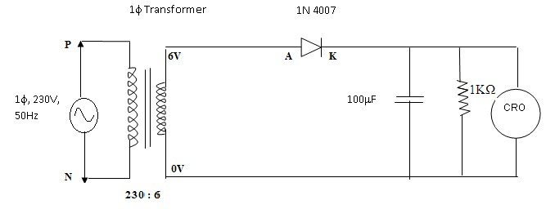

**E-circuit Diagram:**

**1**. 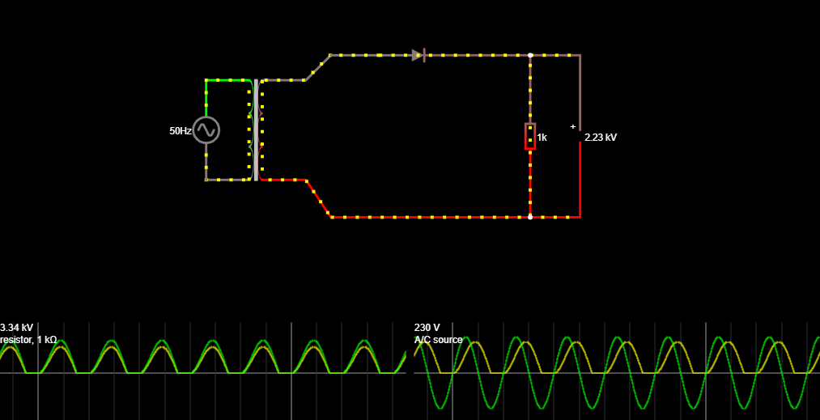

***Half Wave Rectifier without Filter***

**2.** 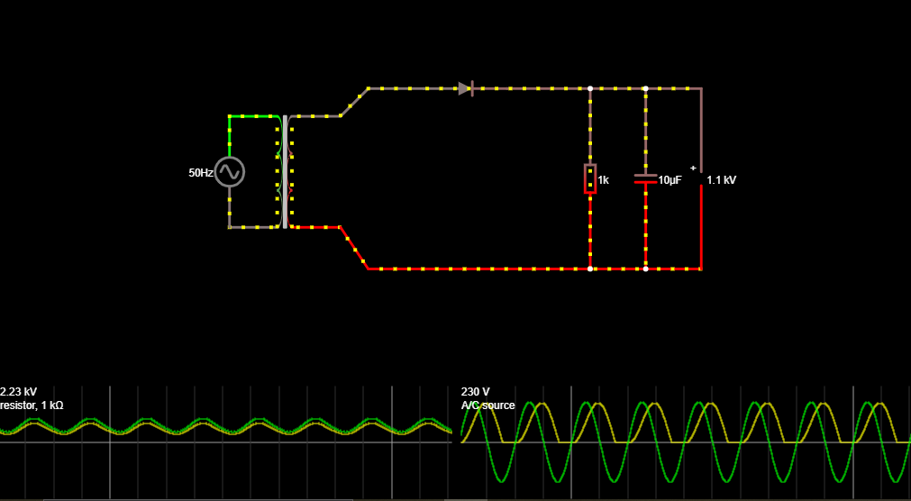

***Half Wave Rectifier with Filter***

# Tabular Column

|  |  |  |  |  |
| --- | --- | --- | --- | --- |
| **Without Filter** |  |  |  |  |
| Vm (V) | Vrms (V) | Vdc (V) | Ripple factor | Efficiency |
| 4.330 | 2.165 | 1.378 | 1.211 | 40.511% |

# With Filter

|  |  |  |  |
| --- | --- | --- | --- |
| Vrpp (V) | Vrms (V) | Vdc (V) | Ripple factor |
| 0.850 | 0.245 | 3.895 | 0.063 |

**Calculations:**

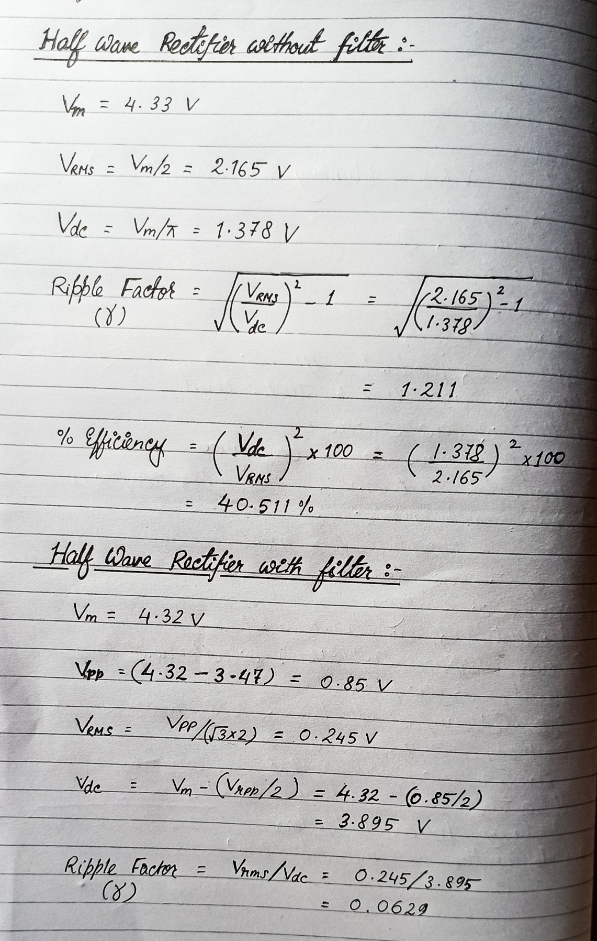

**Model Graph**



**V**

in

)

(

Volts



**t (ms)**



**V**

o

(

Volts

)



**t (ms)**



**t (ms)**



**V**

o

Volts

)

(



**Without Filter**



**With Filter**

**Graph:**

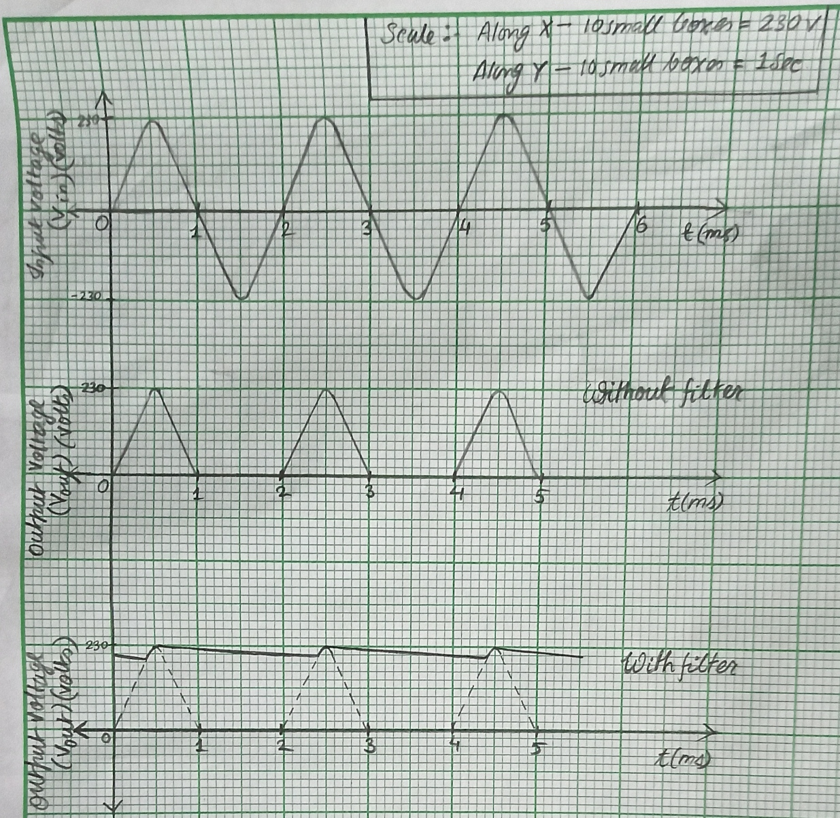

***Half Wave Rectifier***

**Result**:

The performance characteristics of half wave rectifier with/without filter were studied.

|  |  |
| --- | --- |
| **Experiment No. 8 b) Date :** | **SINGLE PHASE FULL WAVE RECTIFIER** |

# Aim

To construct a single phase full-wave rectifier using diode and draw its performance characteristics.

# Apparatus Required Components Required

|  |  |  |  |  |  |  |  |  |
| --- | --- | --- | --- | --- | --- | --- | --- | --- |
| **S.**  **No.** | **Name** | **Range** | **Qty** |  | **S.**  **No.** | **Name** | **Range** | **Qty** |
| 1 | Transformer | 230/(6-0-6)V | 1 | 1 | Diode | IN4007 | 2 |
| 2 | R.P.S | (0-30)V | 2 |
| 2 | Resistor | 1K  | 1 |
| 3 | Bread Board | - | 1 |
| 4 | Capacitor | 100µf | 1 |
| 5 | CRO | 1Hz-  20MHz | 1 |
|  | 6 | Connecting wires | - | Req |

# Formulae

# Without Filter

Without Filter

1. Vrms = Vm / 2
2. Vdc = 2Vm / 
3. Ripple Factor = ((Vrms / Vdc)2 – 1)
4. Efficiency = (Vdc / Vrms)2 x 100

With Filter

1. Vrms = Vrpp /(2* 3)

(ii) Vdc = Vm – V rpp

(iii) Ripple Factor = Vrms’/ Vdc

# Procedure Without Filter

1. Give the connections as per the circuit diagram.
2. A 230 V, 50 Hz AC input given to primary side of the transformer where the phases end of the secondary is connected to anode terminal of the diode.
3. Observe the output across the 1 K ohm load with use of CRO.
4. Plot its performance graph.

# With Filter

1. Give the connections as per the circuit diagram.
2. A 230 V, 50 Hz AC input given to primary side of the transformer where the phases end of the secondary is connected to anode terminal of the diode.
3. Connect the Capacitor across the load.
4. Observe the output across the 1 K ohm load with use of CRO.
5. Plot its performance graph.

# Circuit Diagram

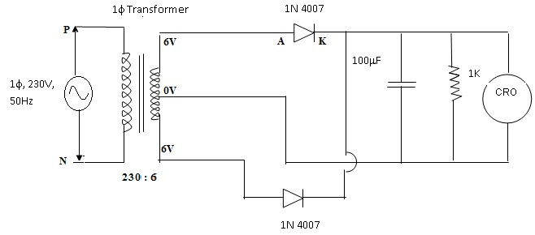

**E- Circuit Diagram:**

**1.** 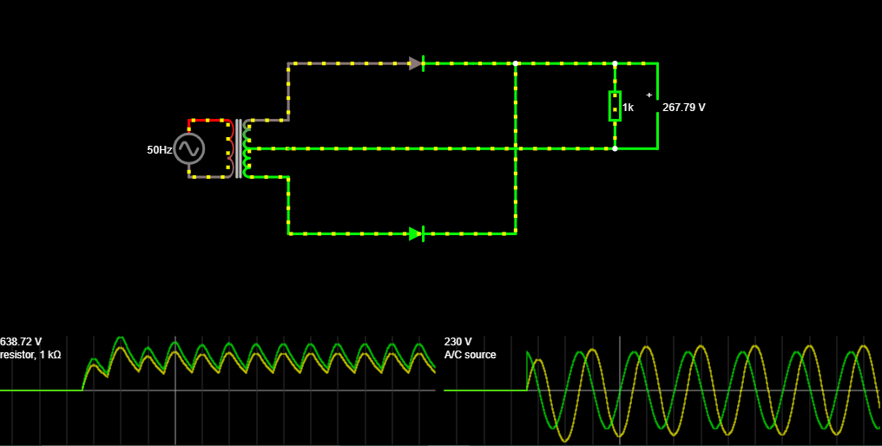

***Full Wave Rectifier without Filter***

**2.**

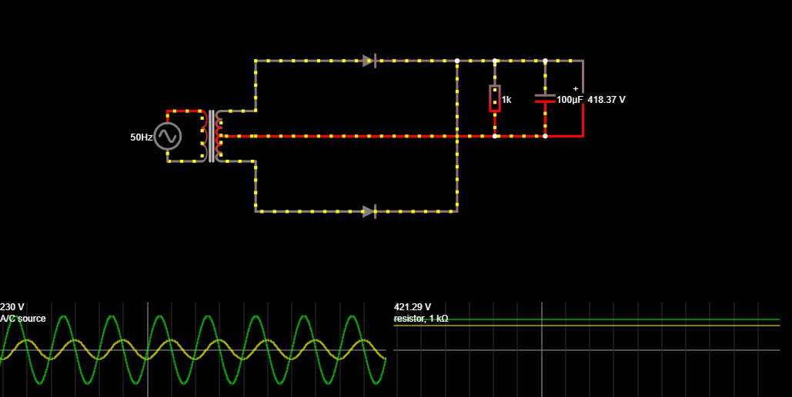

***Full Wave Rectifier with Filter***

# Tabular Column

# Without Filter:

# 

|  |  |  |  |  |
| --- | --- | --- | --- | --- |
| Vm | Vrms | Vdc | Ripple factor | Efficiency |
| 3.67 | 2.595 | 2.336 | 0.483 | 81.035 |

# With Filter:

|  |  |  |  |
| --- | --- | --- | --- |
| Vrms | Vrpp | Vdc | Ripple factor |
| 3.630 | 0.350 | 3.280 | 0.308 |

# Calculations:

# 

# Model Graph



**V**

in

)

Volts

(



**t (ms)**



**V**

o

)

Volts

(



**t (ms)**



**t (ms)**



**V**

o

(

Volts

)



**Without Filter**



**With Filter**

**Graph:**

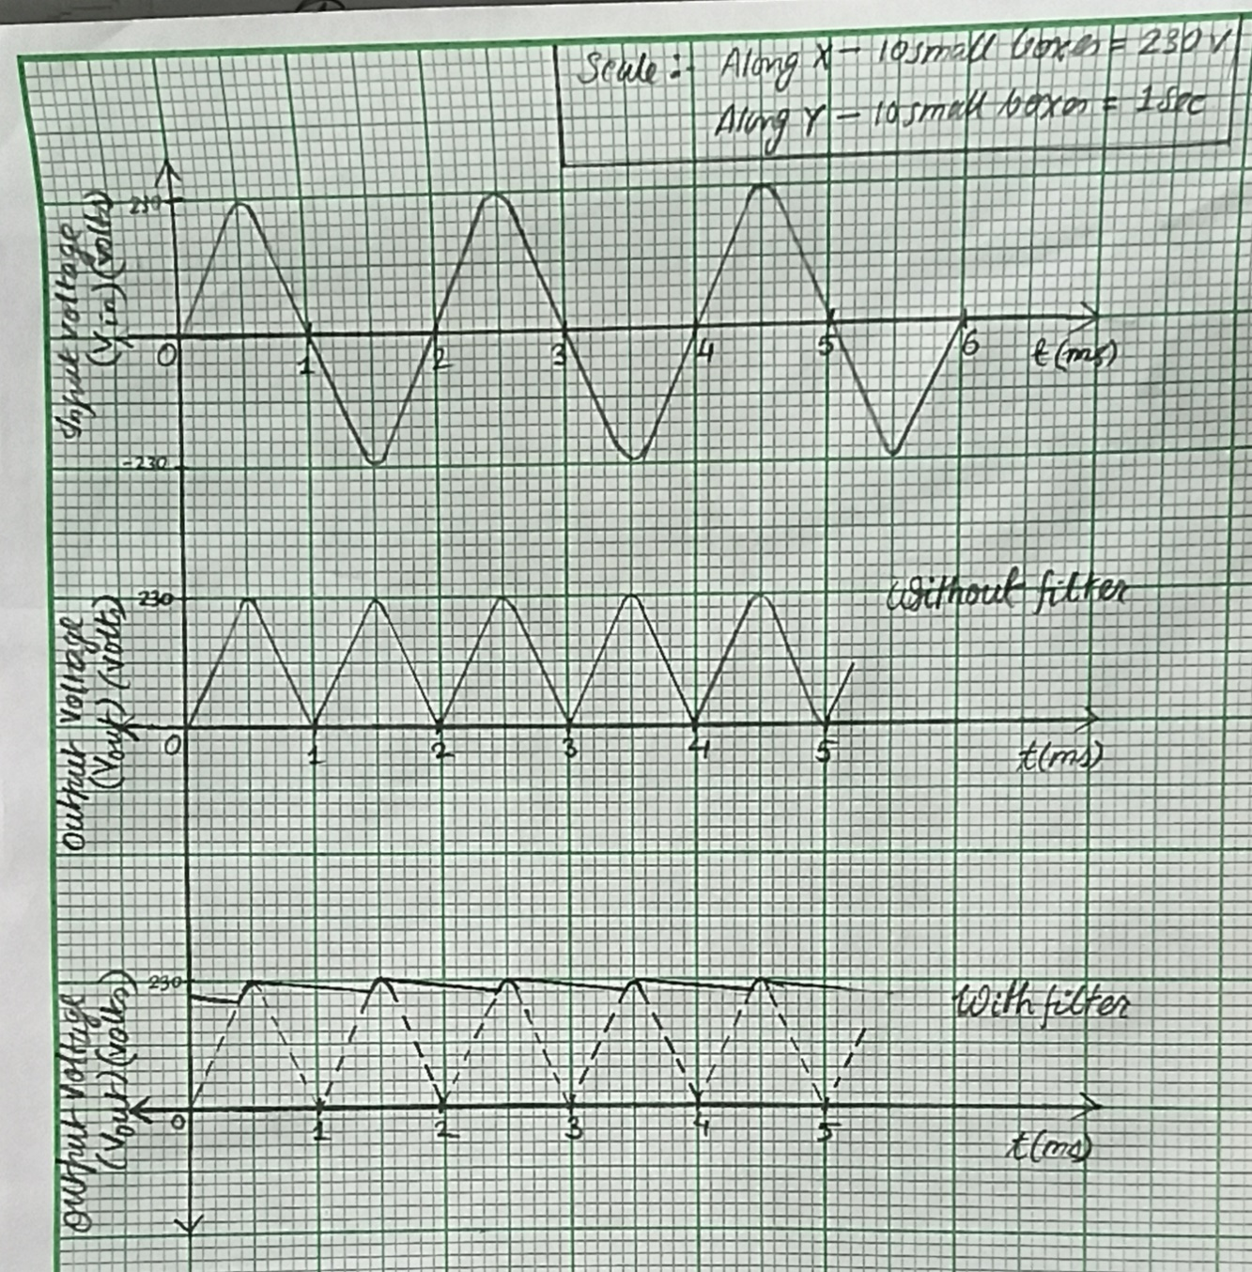

***Full Wave Rectifier***

**Result:**

The performance characteristics of full wave rectifier with/without filter were studied.

**POST LAB QUESTIONS**

1. **What is Transformer Utilization Factor (TUF)?**

**Ans: Transformer Utilization Factor (TUF)** is defined as the ratio of DC power output of a rectifier to the effective Transformer VA rating used in the same rectifier. Effective VA Rating of transformer is the average of primary and secondary VA rating of transformer. The more the value of TUF, the more will be the **utilization**. In other words, the VA rating of required **transformer** will be less if TUF is more and vice versa.

1. **Mention the value of ripple factor for HWR, FWR & rectifier with centre tapped transformer.**

**Ans:** The **ripple factor** of **half wave rectifier** is equal to 1.21 (i.e. γ = 1.21)

The **ripple factor** of full **wave rectifier** is equal to 0.483 (i.e. γ = 0.483)

The **ripple factor** of **rectifier with tapped transformer** is equal to 0.483 (i.e. γ = 0.483)

1. **What is the difference between uncontrolled rectifier and controlled rectifier? Which is advantageous and why?**

**Ans:** **Uncontrolled Rectifiers**: Provide a fixed d.c. output voltage for a given a.c. supply where diodes are used only.

**Controlled Rectifiers**: Provide an adjustable d.c. output voltage by controlling the phase at which the devices are turned on, where thyristors and diodes are used.

**Advantages of controlled rectifier over uncontrolled rectifier are:**

**To compensate** the DC line voltage variations caused by voltage variations on the medium voltage power network. To keep voltage constant even in case of load variations. **To control** the fault current on faults far from the electrical substation and consequently to increase line protection settings.

1. **State the average and peak value of output voltage and current for full wave rectifier and half wave rectifier.**

**Ans: For full wave rectifier;**

* Emax = The peak value of the load voltage pulse
* Eavg = 0.637Emax (the average load voltage)
* Imax = The peak value of the load current pulse
* Iavg = 0.637Imax (the average load current)

**For Half wave rectifier;**

* Eavg (the average load voltage) = .318 × Ema

[Where, Emax = The peak value of the load voltage pulse.]

In most applications the drop across the rectifier tube is small compared to the load voltage, so we can assume Emax in our equation to be the same as the peak value of the input sine wave.

Since the load current has the same wave shape as the load voltage, we can modify the equation so that it applies to the load current. Thus,

* Iavg (the average load current) = 0.318 × Imax

[ Where, Imax = The peak load current]

1. **What is PIV of a diode in half wave and full wave rectifier?**

**Ans:** For Half wave rectifier, during negative half-cycle of the input voltage, the diode is reversed biased, no current flows through the load resistance, RL and so causes no voltage drop across load resistance RL and consequently the whole of the input voltage appears across the diode. Thus, the maximum voltage, that appears across the diode, is equal to the peak value of the secondary voltage i.e. VSM. Thus, for a half-wave rectifier

#### PIV = VSM

For Full wave rectifier, Peak inverse voltage (PIV) is 2Vmax in centre tapped full wave **rectifier**

------------------------------------------------------------------------------------------------------------